# Participants’ Past Experiences & Thoughts about Future Sexual Activity

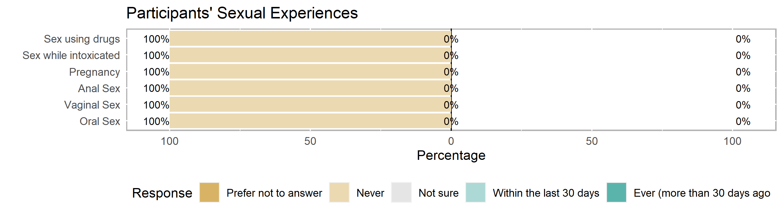

Of the 10 participants who answered these questions on the Pre-Test,

* all 10 (or 100% of) participants reported that they have **never had oral, vaginal, or anal sex**
* none of the participants reported that they have ever caused a pregnancy or have ever been pregnant
* none of the participants reported that they have ever had sex under the influence of alcohol or other drugs

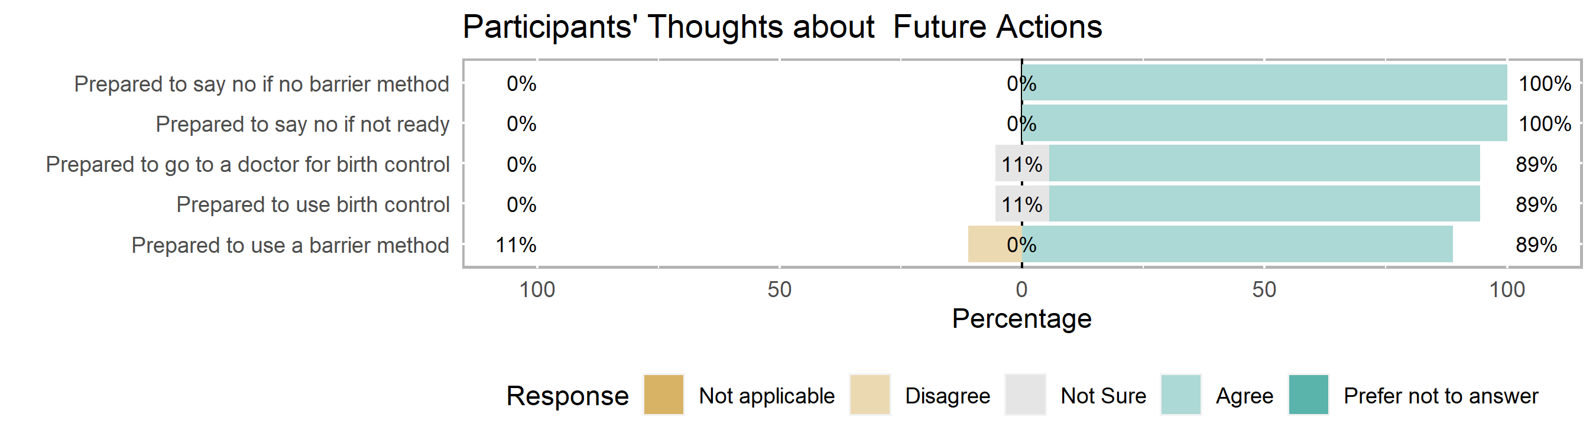

Of the 9 participants who answered these questions on the Pre-Test,

* all 9 (or 100% of) participants agreed that they would be **prepared to say no** if they did not want to have sex or if someone wanted to have sex with them without a barrier method. (*Not shown: one participant accidentally took the Post-Test instead of the Pre-Test. They disagreed to both of these statements.)
* One participant reported they were not sure if they would use **birth control** if they or their partner were worried about getting pregnant.
* One participant reported they were not sure if they could **go to a doctor** for birth control.

# Participants’ Knowledge about Sexual & Reproductive Health

The knowledge portion of the Pre-Test consists of 16 short-answer, multiple-choice, check-all-that-apply, and true/false questions about relationships, birth control (e.g., IUD, implant, shot, ring, patch, pill), and barrier methods (e.g., condoms, dental dams). Participants could earn partial credit on check-all-that-apply questions for a total of 17 possible points*.

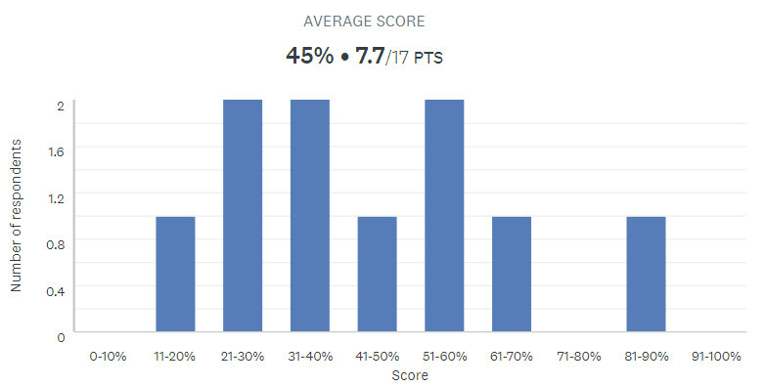

* Range: 18% to 88% correct
* Median: 38% correct
* Mean: 8 out of 17 possible points* or 45% correct   
  (right skew: higher-scoring outliers pulling the distribution to the right)
* Mode: tri-modal
* Standard deviation: 23% (quite the spread of scores)

On average, participants in this group earned 8 out of 17 possible points[1] or got 45% of the Pre-Test correct. The following table includes the number of participants (and percent of the group in parentheses) who answered each question correctly. These were the most difficult questions for your group:

# Highlights & Recommendations

|  |  |  |  |
| --- | --- | --- | --- |
| **Question**\* | **Pre- Test** | **Post-Test** | **Notes** |
| Q34: True or **False**? Water-based lubricants can cause latex condoms to break. | 1 (10%) |  | 4 participants were not sure. |
| Q36: **True** or False? You can get emergency contraception (like Plan B) without a prescription. | 2 (20%) |  | 6 participants were not sure. |
| Q25: What is PrEP (Pre-Exposure Prophylaxis)? | 3 (30%) |  |  |
| Q35: **True** or False? Emergency contraception (like Plan B) can be taken up to 5 days (or 120 hours) after having unprotected sex in order to prevent pregnancy. | 4 (40%) |  |  |
| Q24: Which of the following is FALSE about consent? | 4 (40%) |  | 1 participant (incorrectly) thought that someone who is incapacitated by alcohol or drugs can give consent freely. |
| Q31*: If used correctly, withdrawal (or pulling a penis from a vagina before ejaculating) is effective in protecting people from which of the following? (Check all that apply: **Neither** pregnancy nor STIs.) | 2 (20%) |  | 5 participants (incorrectly) thought that withdrawal could prevent pregnancy. 4 participants (incorrectly) thought withdrawal could prevent STIs. |
| Q29*: If used correctly, an external/male condom made out of lambskin (that covers a penis or sex toy) is effective in protecting people from which of the following? (Check all that apply: **Pregnancy** only.) | 4 (40%) |  | 4 participants (incorrectly) thought that lambskin condoms cannot prevent pregnancy nor STIs. 3 participants (incorrectly) thought lambskin condoms could prevent STIs. |
| Q26*: If used correctly, abstinence (or choosing not to have sex) is effective in protecting people from which of the following? (Check all that apply: **Pregnancy & STIs**.) | 7* (70%) |  | 4 participants correctly identified that abstinence prevents pregnancy. 5 participants correctly identified that abstinence prevents STIs. |
| Q28*: If used correctly, an external/male condom made out of latex, polyurethane, or polyisoprene (that covers a penis or sex toy) is effective in protecting people from which of the following? (Check all that apply: **Pregnancy & STIs**.) | 7* (70%) |  | 7 participants correctly identified that synthetic condoms could prevent pregnancy. 2 participants correctly identified that synthetic condoms could prevent STIs. |

*Participants were able to check-all-that-apply for some questions to earn partial or full credit.

# Participants’ Demographics (for reporting purposes to the Office of Population Affairs)

|  |  |  |
| --- | --- | --- |
| **Reach for Group PAYC021621** | | |
| *Reach* | | *Freq* |
| Gender | | |
|  | Male | 6 |
|  | Female | 4 |
|  | Transgender | 0 |
|  | Did not identify (?) | 0 |
|  | Gender not reported | 0 |
| Race | | |
|  | White | 0 |
|  | Black | 9 |
|  | Asian | 0 |
|  | Alaska Native | 0 |
|  | Native Hawaiian | 0 |
|  | Multiracial | 1 |
|  | Race not reported | 0 |
| Age (years) | | |
|  | 12 | 5 |
|  | 14 | 5 |
| Grade | | |
|  | 6th Grade | 3 |
|  | 7th Grade | 2 |
|  | 8th Grade | 4 |
|  | 9th Grade | 1 |
| Note: n=10; one participant took the Post-Test instead of the Pre-Test thus skipped the  demographics portion of the survey. | | |

One out of 11 participants took the Post-Test instead of the Pre-Test thus skipping the demographics portion of the survey.

There were also 2 participants with the same initials and birthdate but different genders. This is either the same person or fraternal twins:

|  |  |  |  |
| --- | --- | --- | --- |
|  | **IP Address** | **Time Spent** |  |
| P1 | 107.77.233.4 | 1:34 to 1:47 | (13 min) |
| P9 | 107.77.236.113 | 1:43 to 2:08 | (25 min) |

Because of the different IP addresses (thus different devices) and slight overlap in time, I’d conclude that these are fraternal twins. Also, the first participant to take the Pre-Test did so very quickly and scored higher. There would be little reason for this person to take the Pre-Test again, take longer, and perform more poorly.

While the group is evenly split by age, participants come from many grade-levels. This may impact individual understanding and group rapport, if participants do not regularly interact with one another.

1. Participants were able to check-all-that-apply for some questions to earn partial or full credit.